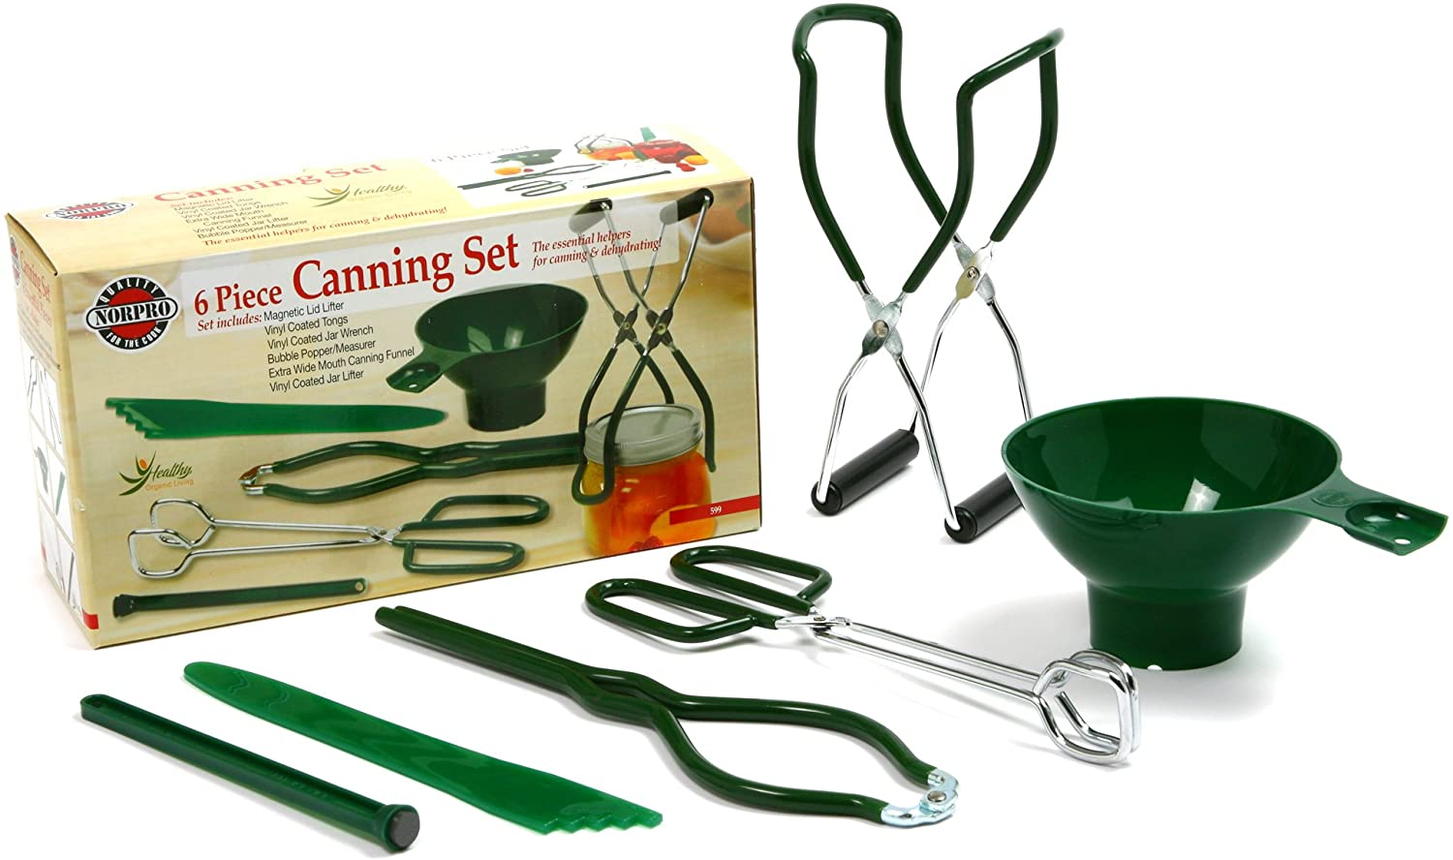

https://i.imgur.com/PLtK0F3.jpg